Support with APNS Plug

1. Introduction

This plug will explore how send post user query with query category and query text and also show support history. User can see support history in details with all questions and reply from server. User also rates the server reply.

This plug implemented with APNS configuration. User will notify during custom or server side reply to submitted query.

2. Pre-requisites:

Language: Swift 4.0 and above

IDE: Xcode 9 and above

3. Features list

1. Posting query.
2. Query history.
3. Query details with question and reply.
4. Rate to server reply.
5. APNS.
6. Notification internal navigation.
7. Error message handling.

4. Screenshots

**Description**: Default page where need to select compulsory main category.

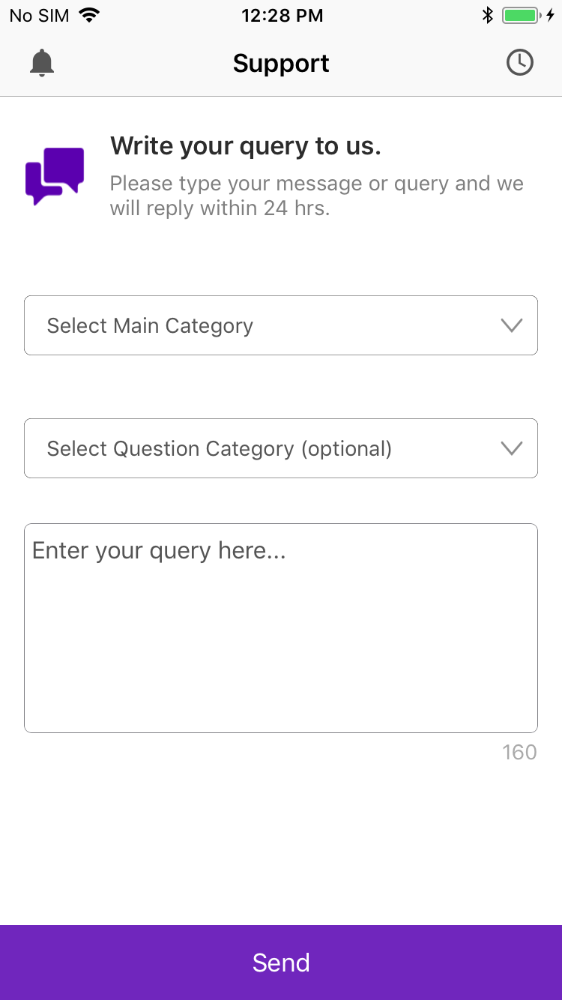

**Description**: Showing the posted queries.

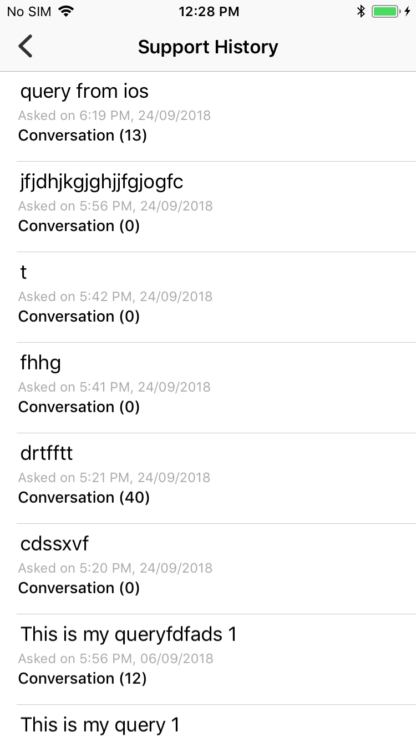

**Description**: Showing the support query details with server reply and user questions.

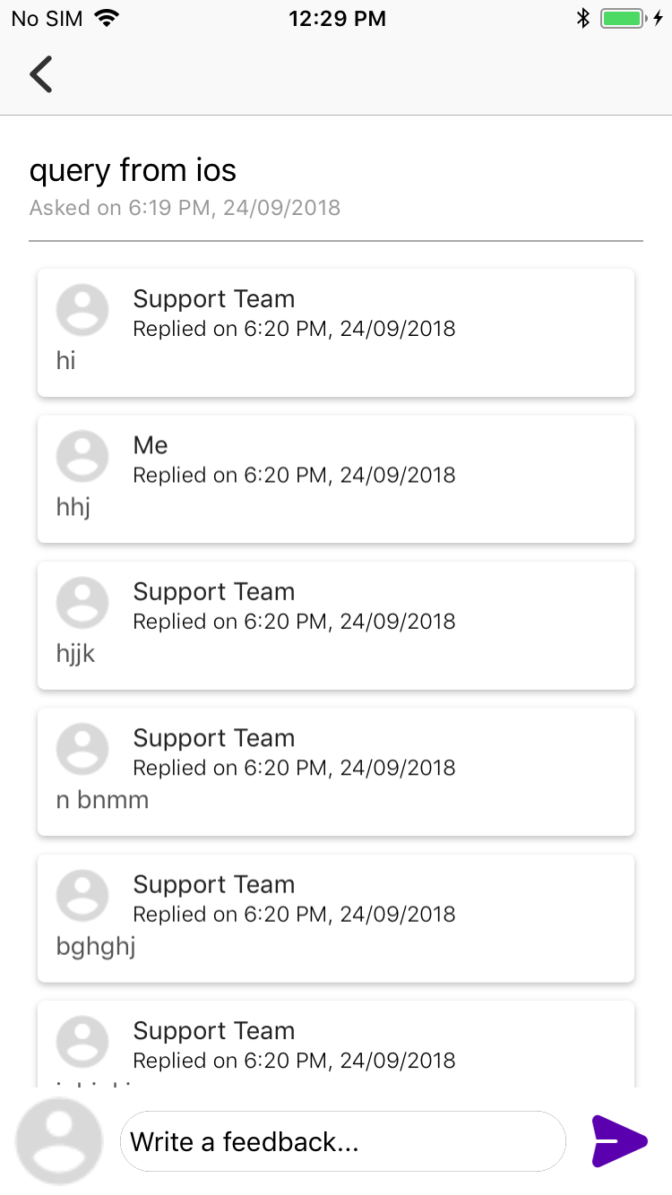

**Description**: User can rate the server reply.

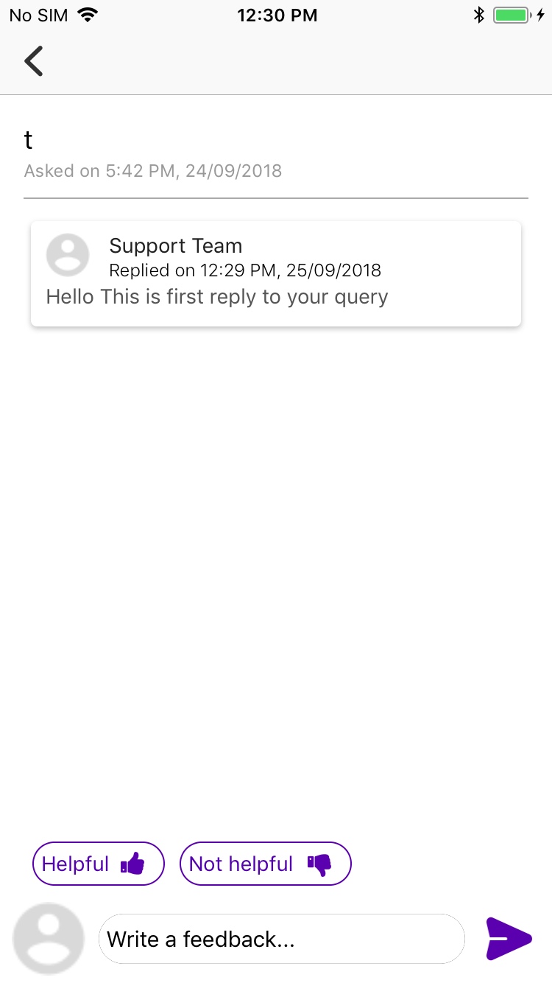

**Description**: Showing all notification.

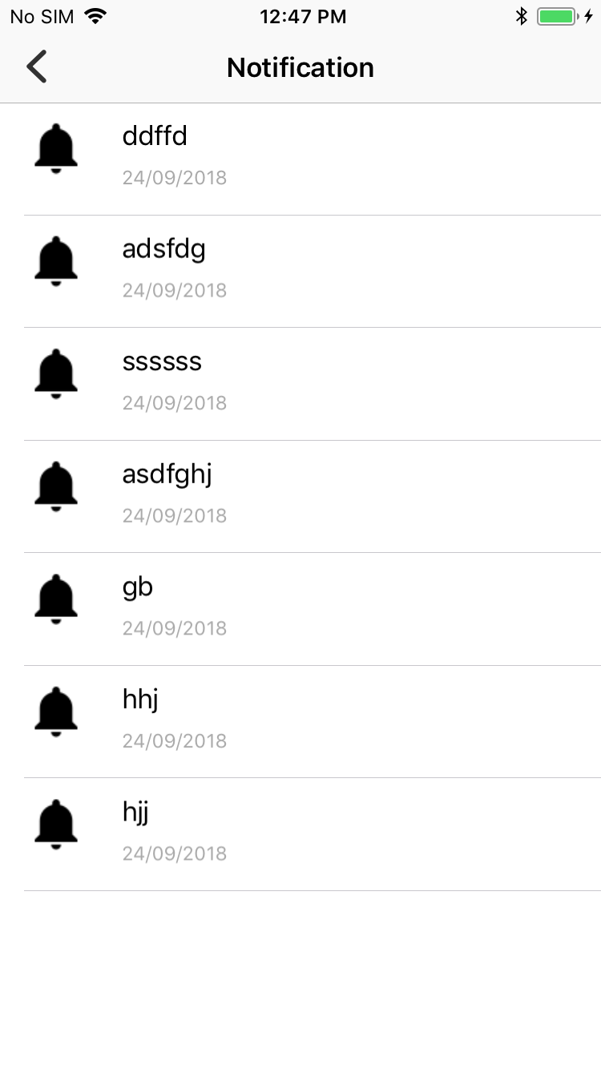

**Description**: Showing notification when app closed or in background.

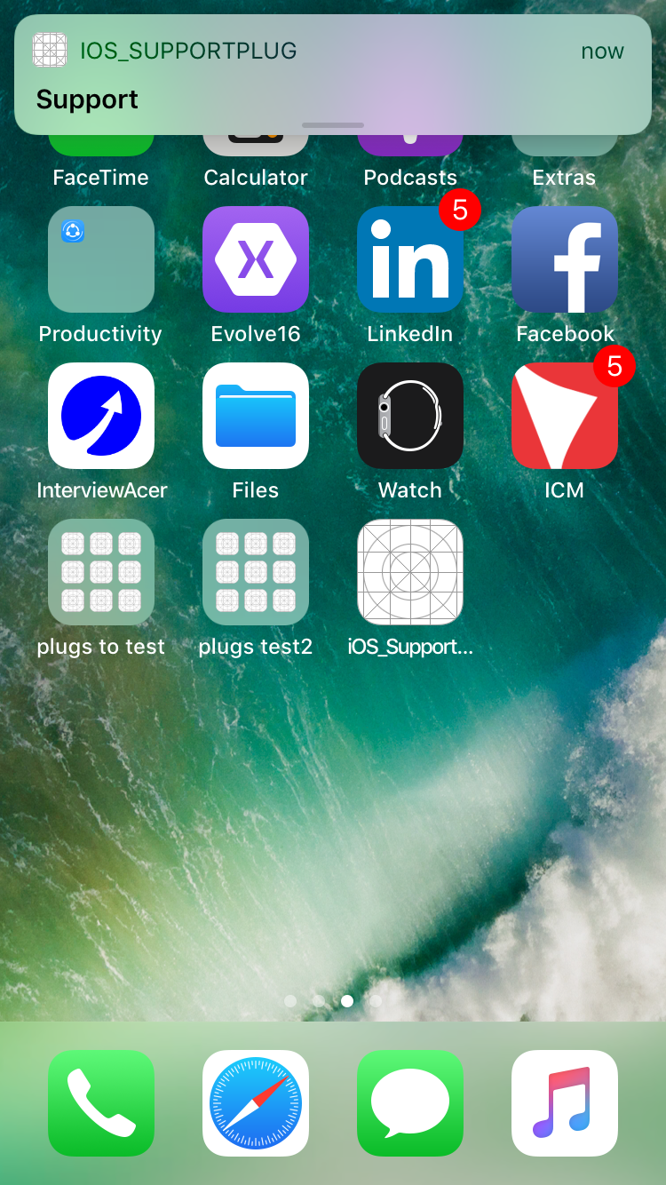

**Description**: Showing APNS banner when app in foreground.

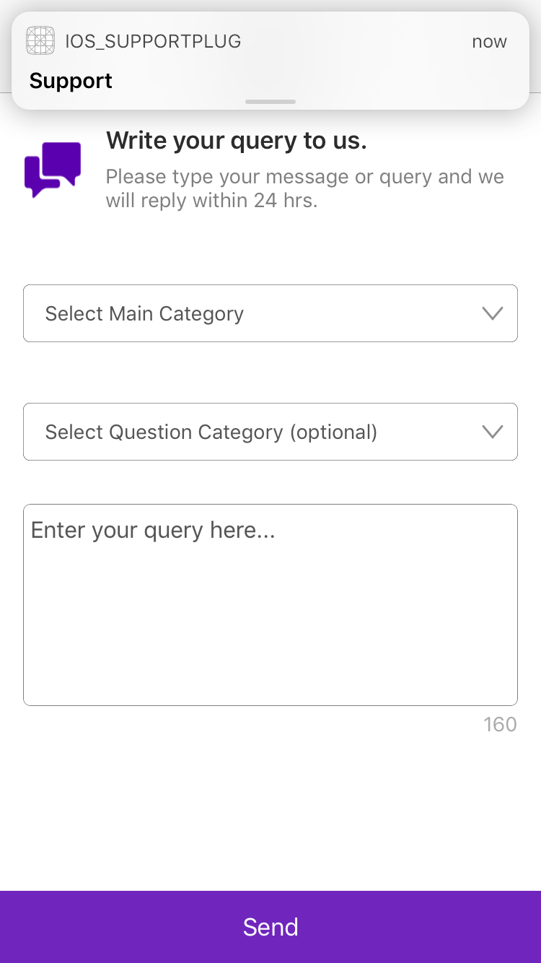

**Description**: Navigate to respected page.

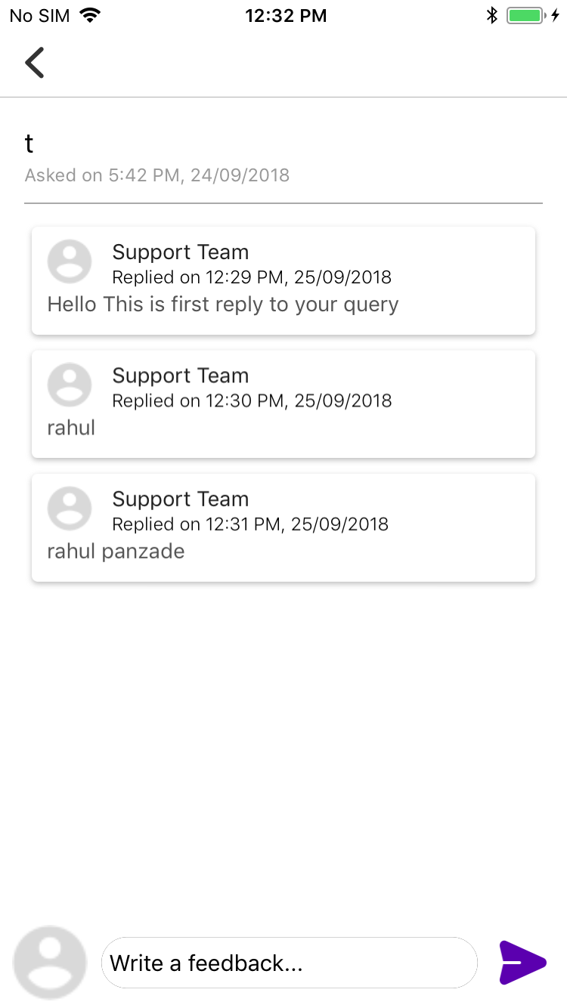

5. Contact us / Support

[Support@plug-able.com](mailto:Support@plug-able.com)

Reference link: <https://developer.apple.com/library/archive/documentation/NetworkingInternet/Conceptual/RemoteNotificationsPG/APNSOverview.html#//apple_ref/doc/uid/TP40008194-CH8-SW1>

<https://www.raywenderlich.com/584-push-notifications-tutorial-getting-started>

<https://github.com/AssistoLab/DropDown>

<https://www.appcoda.com/firebase-push-notifications/>